Name:_______________________
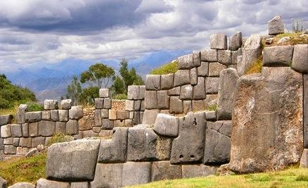
Aztec, Maya, and Incan WebQuest

Begin your webquest by using the links below to answer the questions and complete the tasks.
- Geography: On the map provided…
Identify where the Incan, Mayan, and Aztec civilizations were located. Label them on the map!
http://www.classzone.com/net_explorations/U4/U4_article1.cfm
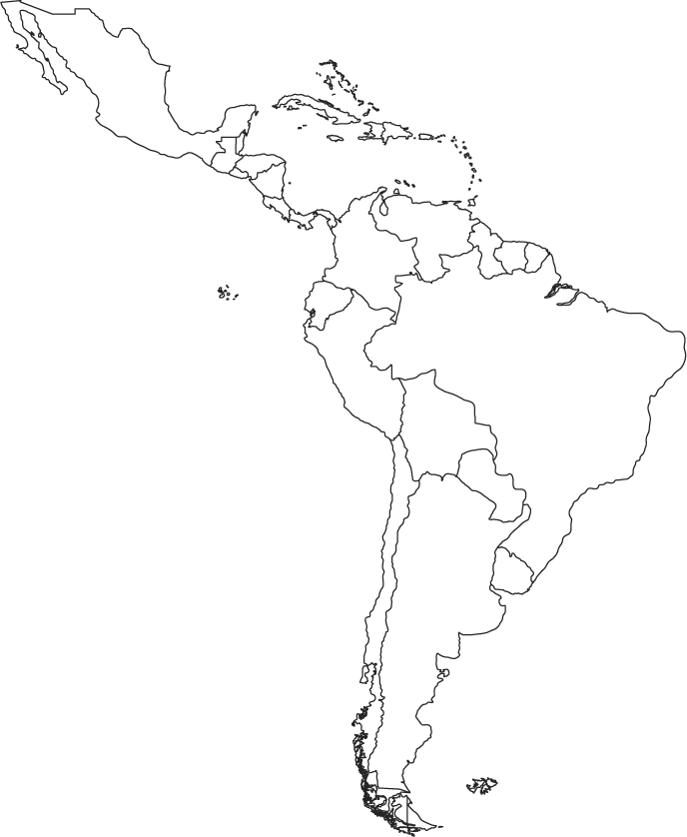
In what modern countries would you have found these civilizations? Label them on the map!
http://www.worldatlas.com/webimage/countrys/na.htm (Maya and Aztec)
http://www.worldatlas.com/webimage/countrys/sa.htm (Inca)

- Religions:
- Were these empires polytheistic or monotheistic?

- Name at least one god from each civilization. What they were the god of? http://mayaincaaztec.com/religion.html
  - Aztec-
  - Maya-
  - Inca-

- Use the following site to answer the next two questions:
  - http://www.history.com/topics/ancient-history/pyramids-in-latin-america

    - Why were the pyramids of the Aztec and Maya built?

    - What happened at the Aztec and Mayan temples?

Aztecs: http://www.ancient.eu/Tenochtitlan/ .
- What was the name of the Aztec capital/main city?

- Describe what the city was like in 3 sentences.

- Aztec Calendar-https://www.azteccalendar.com/azteccalendar.html
  - How many months did the Aztecs have?

  - How is their calendar alike and different from ours?

- Decline- http://www.aztec-history.com/fall-of-the-aztec-empire.html
  - What were the main reasons for the fall of the Aztec Empire?

  - Who was Hernando Cortez and how did he help bring about the end of the Aztec civilization?

Maya:

- Calendar- http://www.webexhibits.org/calendars/calendar-mayan.html
  - How many calendars did the Maya have? How accurate were they?

- Decline- http://www.history.com/topics/maya (Watch the video and read the bottom of the article.)
  - Do we know why the Maya civilization declined?

Inca: http://www.history.com/this-day-in-history/pizarro-traps-incan-emperor-atahualpa

- Who was Atahualpa?

- Who was Francisco Pizarro and how did he help bring about the end of the Incan civilization?

- Religion- http://www.windows.ucar.edu/cgi-bin/tour_def/mythology/inti_sun.html
  - Who was Inti?

- Technology-
  - Why were Inca roads so impressive? http://www.pbs.org/wgbh/nova/ancient/lost-inca-empire.html

  - Did Incans write and keep records? http://archaeology.about.com/od/americanancientwriting/a/quipu.htm

  - What is Macchu Pichu and who “found it”? http://www.pbs.org/wgbh/nova/ancient/lost-inca-empire.html

- Civilizations Paragraphs:

Write two paragraphs, one discussing the civilization you would have wanted to live in and the other paragraph should state why you would not want to live in the other two. YOU ARE NOT ALLOWED TO TELL ME “I wouldn’t want to live in any of them because I don’t like them, they aren’t modern, or any other reason like that”.
________________________________________________________________________________________________________________________________________________________________________________________________________________________________________________________________________________________________________________________________________________________________________________________________________________________________________________________________________________________________________________________________________________________________________________________________________________________________________________________________________________________________________________________________________________________________________________________________________________________________________________________________________________________________________________________________________________________________________________________________________________________________________________________________________________________________________________________________________________________________________________________________________________________________________________________________________________________________________________________________________________________________________________________________________________________________________________________________________________________________________________________________________________________________________________________________________________________________________________________________________________________________________________________________________________________________________________________________________________________________________________________________________________________________________________________________________________________________________________________________________________________________________________________________________________________________________________________________________________________________________________________________________________________________________________________________________________________________________________________________________________________________________________________________________________________________________________________________________________________________________________________________________________________________________________________________________________________________________________________________________________________________________________________________________________________________________________________________________________________________________________________________________________________________________________________________________________________________________________________________________________________________________________________________________________________________________________________________________________________________________________________________________________________________________________________________________________________________________________________________________________________________________________________________________________________________________________________________________________________________________________________________________________________________________________________________________________________________________________________________________________________________________________________________________________________________________________________________________________________________________________________________________________________________________________________________________________________________________________________________________________________________________________________________________________________________________________________________________________________________________________________________________________________________
_________________________________________________________________________________________________________________________________________________________________________________________________________________________________________________________________________________________________________________________________________________________________________________________________________________________________________________________________________________________________________________________________________________________________________________________________________________________________________________________________________________________________________________________________________________________________________________________________________________________________________________________________________________________________________________________

