Midterm part II:
Review
UNIT 1: ANCIENT CIVILIZATIONS AND RELIGIONS
- Which geographic features determined the location of the early civilizations of Egypt, Mesopotamia, China, and India?

- The epilogue laws of justice which Hammurabi, the wise king, established; a righteous law, and pious statute did he teach the land. . . . the decisions which I have made will this inscription show him; let him rule his subjects accordingly, speak justice to them, give right decisions, root out the miscreants and criminals from this land, and grant prosperity to his subjects. Hammurabi, the king of righteousness, on whom Shamash has conferred right (or law) am I. My words are well considered; my deeds are not equaled; to bring low those that were high; to humble the proud, to expel insolence. Code of Hammurabi, Epilogue

How did implementation of codified laws such as the Code of Hammurabi affect the people of ancient societies?

- How did Pericles influence the functioning of Athenian government?

- Christianity, Islam, and Judaism are similar in that they all ask their followers to do what?

- “Most Gracious, Most Merciful;”
“Master of the Day of Judgment.”
“Thee do we worship, And Thine aid we seek.”

This translated quotation from the Qur’an refers to which deity?

- Analyze the contributions of ancient Roman culture. Explain them below.

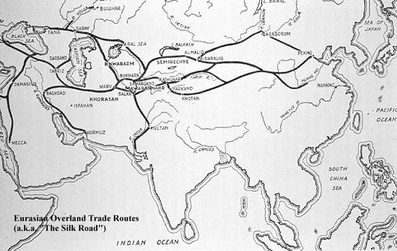

According to the map, how was the Silk Road associated with the development of cities?

UNIT 2: EXPANDING ZONES OF EXCHANGE
- The Golden Age of Greece and the Golden Age of Islam were similar how?

- In Western Europe, the Middle Ages began after the collapse of which empire?

- During the feudal period in Europe, power and position in society were based on the amount of land possessed. How did feudalism work?

- During the early Middle Ages, western European societies revolved around the Roman Catholic Church. Why was the Church such an important part of their everyday lives?

- How was European society affected by the Crusades? Explain the impacts of the Crusades.

- One way in which the code of chivalry in Europe and the code of Bushido in Japan were similar is that both codes were intended to do what?

- “…Christian warriors, He who gave His life for you, today demands yours in return. These are combats worthy of you, combats in which it is glorious to conquer and advantageous to die. Illustrious knights, generous defenders of the Cross, remember the examples of your fathers who conquered Jerusalem, and whose names are inscribed in Heaven; abandon then the things that perish, to gather unfading palms, and conquer a Kingdom which has no end.”-St. Bernard of Lairvaux
After analyzing the above quote, what was the author trying to have the people do? Make sure you pay attention to the time period and the major events happening during this time.

UNIT 3: GLOBAL INTERACTIONS
- How did the printing revolution contribute to increased global interaction?

- An important characteristic of Renaissance humanists was their emphasis on what? Explain why this is important to the Renaissance.

- What is humanism?

- How did the new ideas and scientific advances of the Renaissance challenge the Catholic Church?

- Martin Luther’s posting of the Ninety-Five Theses is considered by many to be a turning point in history. Why?

- Which historical periods are in the proper chronological order?
  - Neolithic>Paleolithic>Mesopotamia>Renaissance>Ancient Greece>Roman Empire>Middle Ages
  - Paleolithic>Neolithic>Mesopotamia>Ancient Greece>Roman Empire>Middle Ages>Renaissance
  - Ancient Greece>Paleolithic>Neolithic>Mesopotamia>Roman Empire>Renaissance>Middle Ages
  - Paleolithic>Neolithic>Mesopotamia>Ancient Greece>Middle Ages>Roman Empire>Renaissance

