MIDTERM PART I: review

SECTION 1: THE OTTOMAN EMPIRE
- Tell me about the Ottoman empire in the 1400s and 1500s.

What city did the Ottoman Empire conquer in 1453 putting an end to the Byzantium Empire? How?

SECTION 2: MESOAMERICAN / SOUTH AMERICAN CIVILIZATIONS
- In Latin America, the Maya and the Aztec civilizations were similar how?

- A study of the Maya, Aztec, and Inca civilizations of Latin America would show that these civilizations were better off before or after Europeans arrived? WHY?

- What was a lasting impact of pre-Columbian civilizations of Latin America cultures?

SECTION 3: EXPLORATION AND ENCOUNTERS
- Analyze the reasons the Spanish conquistadors were able to conquer the Aztec and Inca empires and explain one.

- Explain one major effect of the European slave trade on Africa.

- The astrolabe and improvements in cartography helped Europeans to do what?

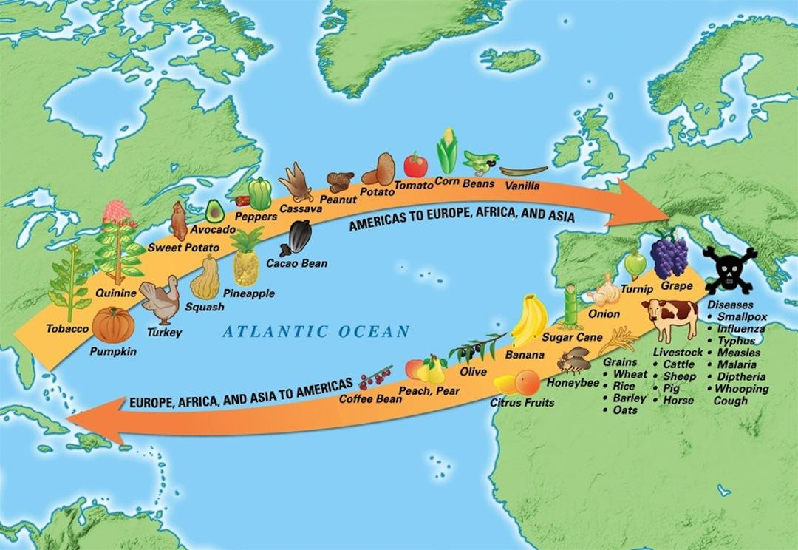

What event that occurred in the 15th and 16th centuries is depicted in this image?

- Which of these events during the Age of Exploration was a cause of the other three?
  - Europeans brought food, animals, and ideas from one continent to another
  - European diseases had an adverse effect on the native populations of new territories
  - warfare increased as European nations competed for land and power
  - advances in learning and technology made long ocean voyages possible

EXPLAIN WHY.

- Explain the theory of mercantilism and the part of the colonies.

- What was the result of explorers’ voyages illustrated on this map?
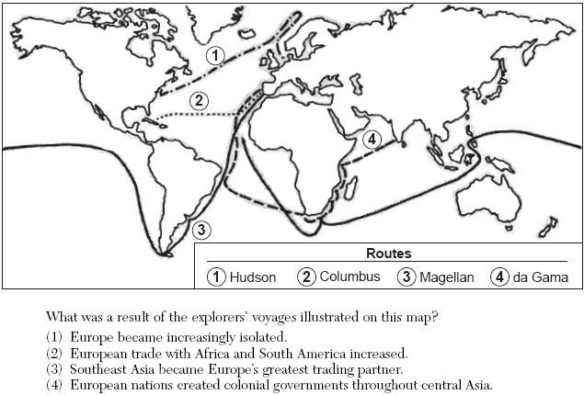

SECTION 4: ABSOLUTISM
- During the Age of Absolutism (1600s and 1700s), European monarchies sought to do what with the people?

- Many European monarchs of the 1600s maintained that they should have absolute power to rule. Why?

- The theory justifying a monarch’s rule by God’s authority is called

- Explain what an absolute monarch is and their ideas of government.

- Which change was introduced by Peter the Great to Russia in the 17th century?

- “…Here a new city shall be wrought [built]…
Shall break a window to the West…
Here flags of foreign nations all
By waters new to them will call…”
-Alexander Pushkin, The Bronze Horseman

Which policy was developed to implement the plans described in the poem?

- “The royal power is absolute…Without this absolute authority the king could neither do good nor repress evil. It is necessary that his power be such that no one can escape him.”
Which event was based on ideas that are in direct contrast to the ideas expressed in this statement?

- All merchants, unless they have been previously and publicly forbidden, are to have safe and secure conduct in leaving and coming to England and in staying and going through England both by land and by water to buy and to sell, without any evil exactions, according to the ancient and right customs, save in time of war, and if they should be from a land at war against us and be found in our land at the beginning of the war, they are to be attached without damage to their bodies or goods until it is established by us or our chief justiciar in what way the merchants of our land are treated who at such a time are found in the land that is at war with us, and if our merchants are safe there, the other merchants are to be safe in our land.
Magna Carta, 1297

Based on this passage from the Magna Carta, which basic rights were improved by the English barons?

