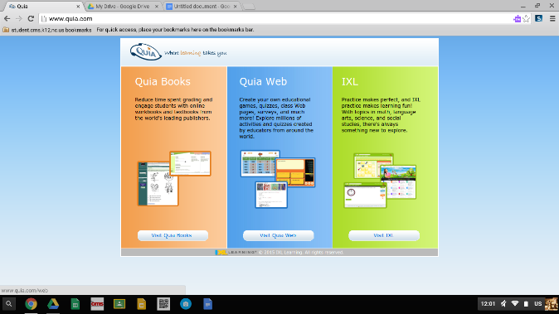
Test Corrections

1.Go to Quia.com
2.Go to Quia Web (BLUE CENTER ONE)
3. Log into Quia (most are firstnamelastname702 password= team)

4.Click on the image on the left of the screen when you log into Quia

5.YOU MUST THEN:
- Write the question
- Put the correct answer
- Write 2-3 sentences on why that answer is correct. Explain the history, context, and answer choice. Write your explanation as if you were explaining the answer to your parent/guardian.

